Experience
Completed by E360 Help Desk
Screen shots, with identifier above the screen shot, so QC person(s) can identify what the screen shot is for. Emails requesting account set up/termination must be added to the ticket for audit purposes.
NOTE: If the user is granted the tier manager role, they also need to be granted their “user” role. This provides access to reply to reviews and has a widget code.

User Setup:
Log into Experience https://app.experience.com/user/signin

From the dashboard, you will click “Hierarchy” and then “Users”
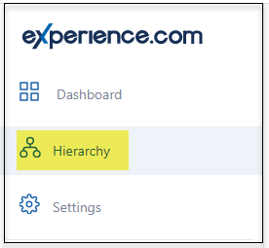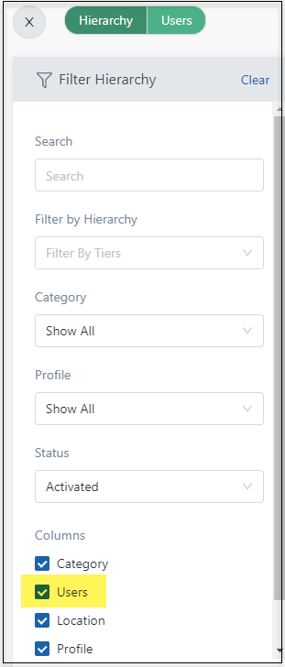

Click “Users”, then “Add New User”
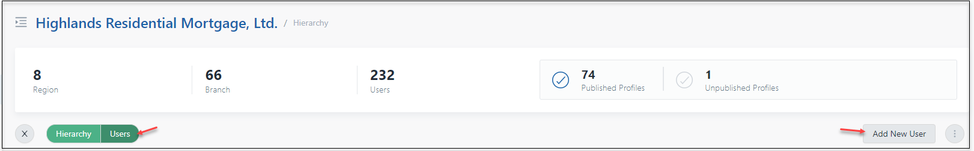

“Add Single User”
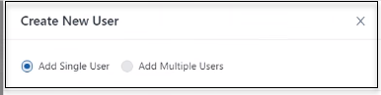
Enter First Name
Enter Last Name
Enter email address
Employee ID
Opt-in to Experience login: Slide to “blue”
Allow Survey Completion: this defaults “blue”
Allow user to expire Survey: this defaults “blue” – Slide to turn off*
Tier: Select Branch Location
Role: Select based on user’s title
Tier Manager – Branch/Sales Manager and above
Agent: Loan Officer/LOA
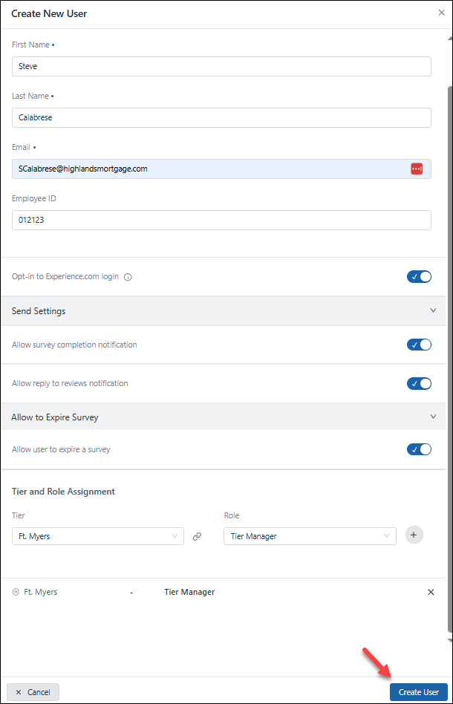

Login Settings & Listings Settings
Do not change: Import Google Posts or Import Facebook Posts
Opt-in to Experience.com login: this defaults “blue”
Import Q &A from Google: this defaults “blue”
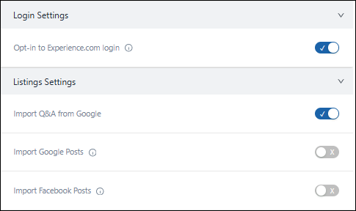

Review Management Settings:
Do not change, Import Google Reviews or Import Facebook Reviews
Allow user to reply to reviews: this defaults “blue”
“Allow user to reply to reviews”: this defaults “blue”
Confirm “Minimum score to reply on reviews” is set to “3” (This can sometimes default to 2.5 or 4)
Allow user to reply using AI: this defaults “blue”
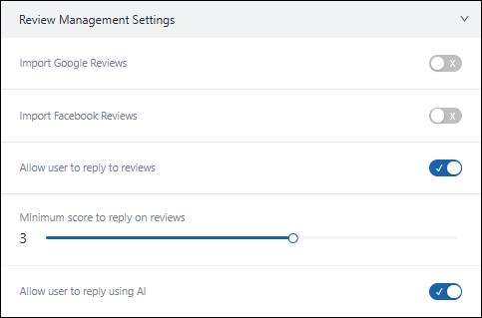

Social Share Settings:
(CONFIRM all settings)
Allow Auto-post – on by default
Minimum score – set at 4.5 by default
Maximum Number of posts per day – Set at 3 by default
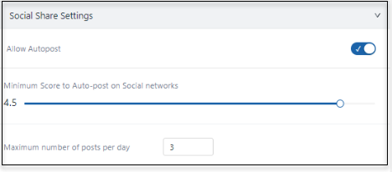
Minimum gap between posts – set at 2 hours 0 minutes by default
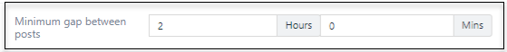
Send Settings for Allow survey completion notification set to blue by default

Allow to Expire Survey
Allow to Expire Survey – toggle off, this is typically toggled on
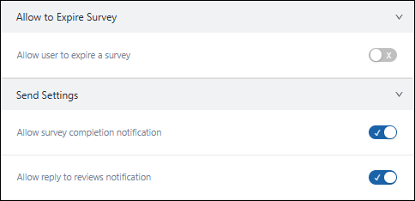
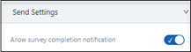

Select “Create User”
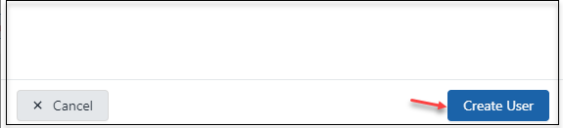
Select “Confirm”
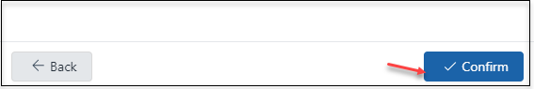

Publish Users site:
From the dashboard, you will click “Hierarchy” and then “Users”. Type User name in “Search Box”

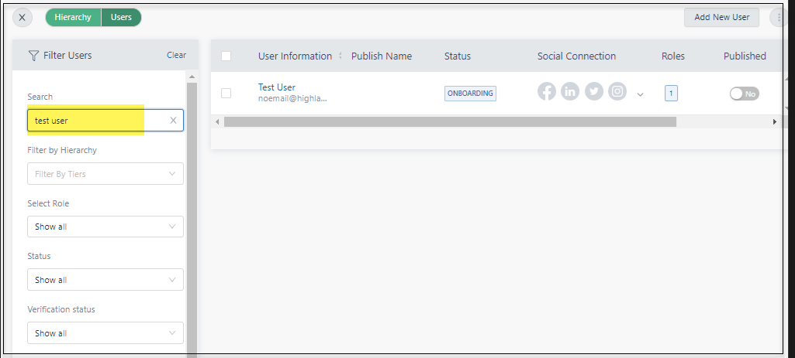

Check Box to left of username, and click of “No” under “Published”
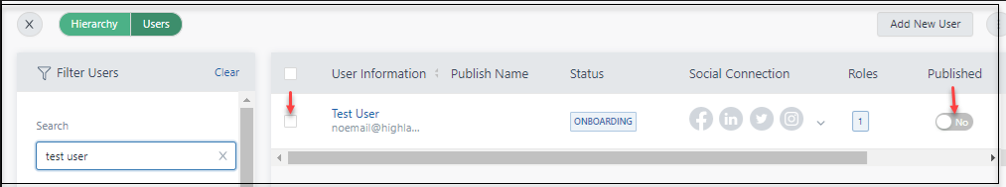

Popup – Click confirm
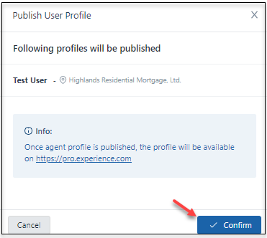
Confirm “Published” is set to “Yes”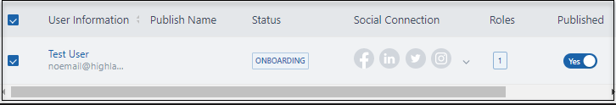

Obtain User Widget for Bigfish
Click “Widgets” from Menu, then “Review Widget”
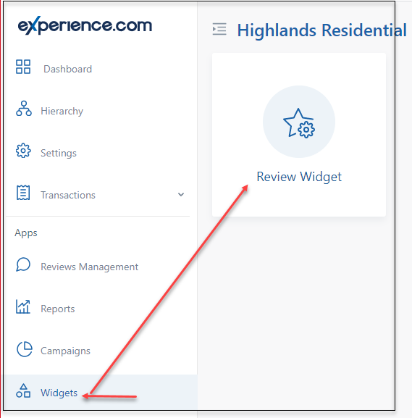
Click on “Basic Review” and Filter By “User”
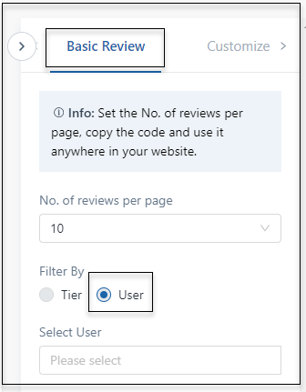

Find agent in the “Select User” Field, then click “Get Code”
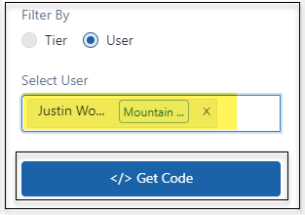

Click on “Copy Code” and provide to Bigfish to update website
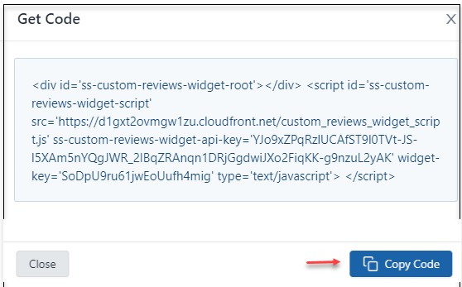

Locating the website link for Total Expert
From the dashboard, you will click “Hierarchy” and then “Users”.
Type User name in “Search Box”

Click on Hamburger menu and select “View Profile”
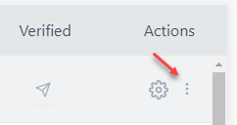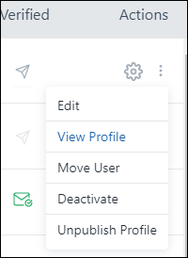
Link noted below will be utilized with Total Expert account (CUSTOM FIELD 3, Application URL) 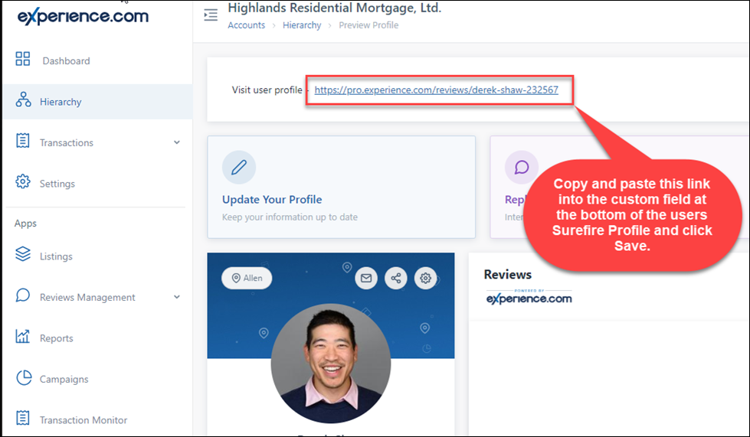

Additional fields (used for new users and editing existing users)
Click “Users” and type name
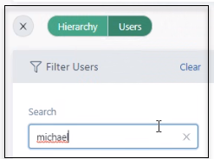
Locate the user and click on “three dots”
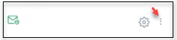
Click on “Edit User”
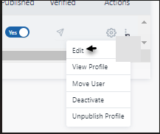
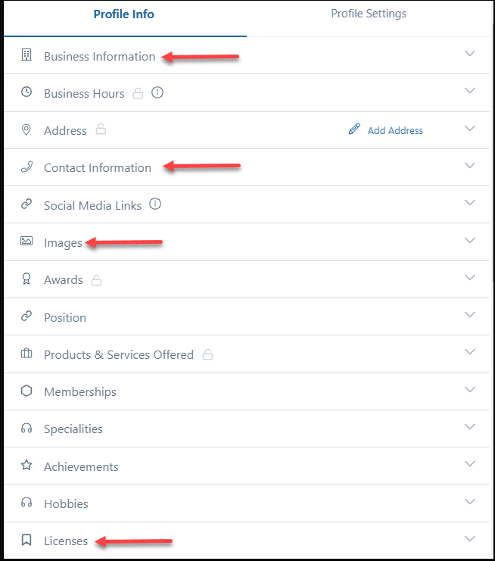

Add “Business Information”
Update Title, replace "Highlands Residential Mortgage, LTD. with Users title
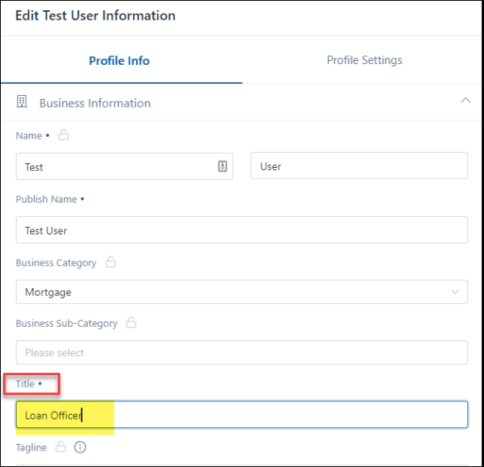

Add “Contact Information”
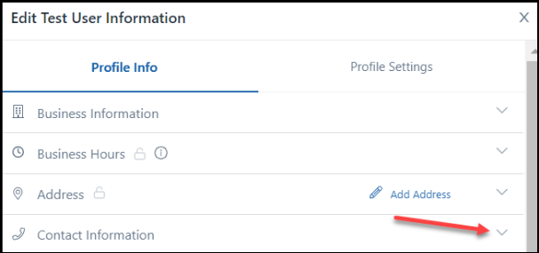

Enter information in highlighted fields
Phone: users office number
Mobile: users cell number
Website URL: HRM user website link
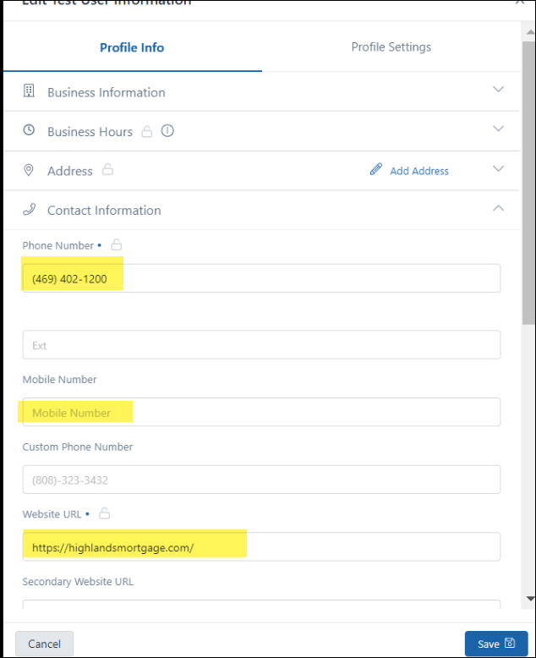

Add “License Name”
Enter users NMLS number: (example NMLS# 123456)
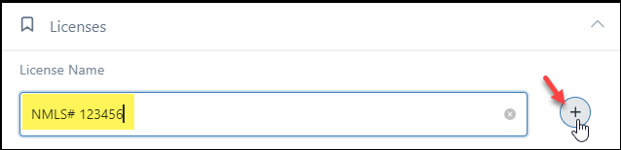

Add Headshot:
Click “Select Images”, then “Upload”. Locate LO picture
Marketing will place users’ headshots into the link below PLEASE NOTE: You must be on Meraki VPN or in a HRM office to access
Click link: http://10.201.127.4:5000/fsdownload/ljgxjQRjU/03_Loan%20Officers

Highlight picture and click enter, then click “Save”
